BATCH: T5

PL-3 ASSIGNMENT NO. 1

**Study of Java Script**

NAME: Priti Sunil Desai

PRN NO. : 22510062

1)Problem Statement 1: Basics of Java Script

Write a JavaScript function that takes an array of numbers as input and returns the

sum of all even numbers in the array. Additionally, create a simple HTML interface with

an input field where the user can enter comma-separated numbers and a button to

trigger the calculation. Display the result below the button.

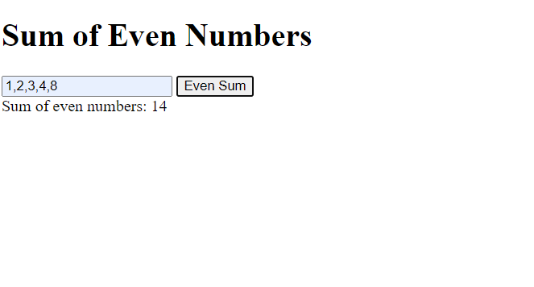

2)Problem Statement 2: Implement a function that validates a password based on the

following criteria:

1. At least 8 characters long.

2. Contains at least one uppercase letter, one lowercase letter, one digit, and one

special character.

3.Create an HTML form with an input field for the password and a "Check Password"

button. Display a message indicating whether the password is valid or not.

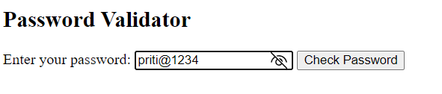

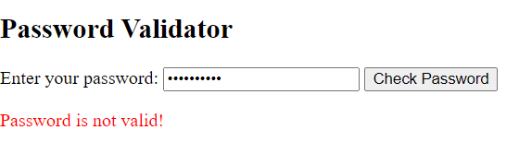

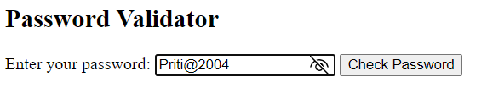

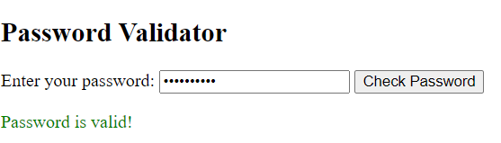

4)Statement 4

Create a basic web page for a fictional online bookstore using HTML, CSS, and JavaScript.

The web page should have the following features:

1. A header with the bookstore name and a navigation menu (Home, Books, Contact).

2.An area to showcase featured books with their titles, authors, and cover images.

3. A section where all available books are displayed in a grid format. Each book should

have an image, title, author, and a button to "Add to Cart".

4. Implement a simple shopping cart functionality using JavaScript. Allow users to add

books to their cart and display the total number of items in the cart on the

navigation menu.

